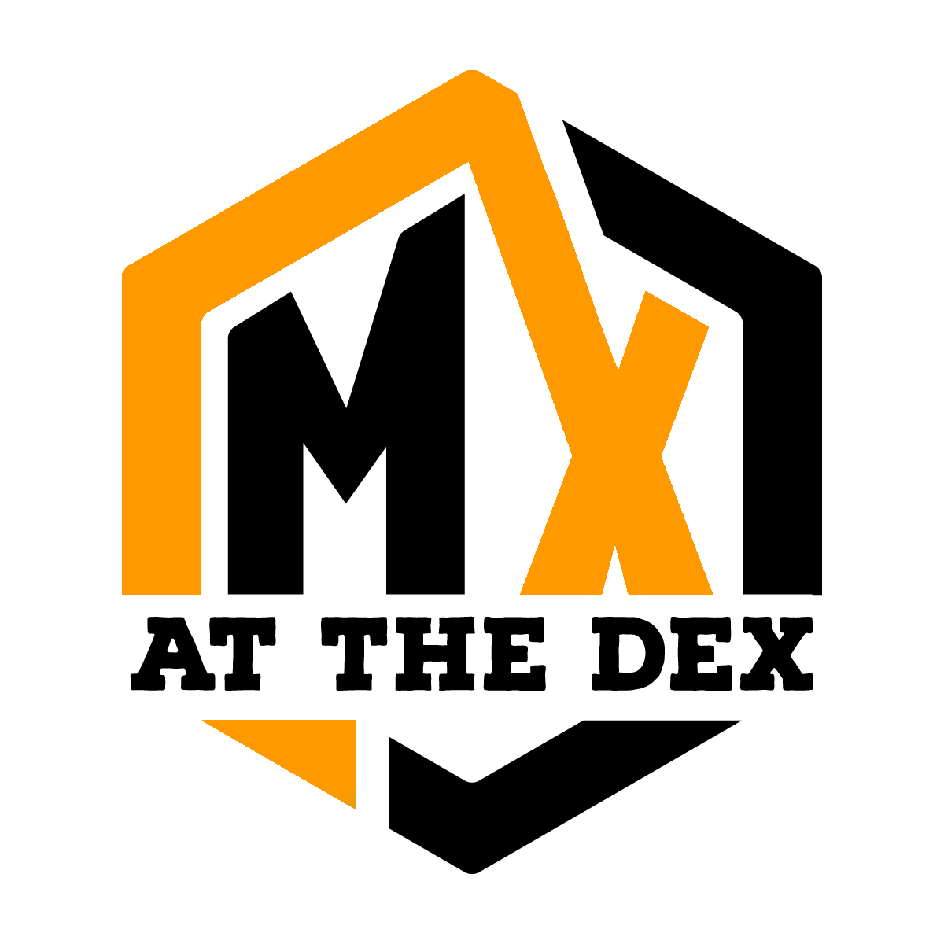
713 Racing Promotions
MX @ the DeX
Huron, South Dakota • www.mxatthedex.com ______________________________________________________________
Dear Supporter,
What a year it was for MX @ the DeX! The 2025 indoor motocross season brought amazing crowds, incredible racing, and a surge of excitement that put Huron on the regional motorsports map. From the roar of the bikes to the energy of packed stands, riders and fans alike helped us make MX @ the DeX an absolute success in year one.
As 713 Racing Promotions looks ahead to 2026, we are shifting to another gear once again. This season will feature expanded race weekends, new youth-focused events, and bigger fan experiences designed to grow our audience and bring even more attention to our sponsors. With consistent media coverage, strong social engagement, and our growing community of dedicated fans, this is the perfect time for businesses to get involved.
We invite you to partner with us for the upcoming 2025–2026 season. Whether through track signage, event sponsorships, or promotional collaborations, your brand will be front and center in front of a passionate, loyal audience that lives for high-octane action.
Let’s build on our success together and make 2026 faster and louder.
If you are new to the program or a sponsor from last year, please watch the 2025 stinger video on YouTube to see what the talk is all about. https://www.youtube.com/watch?v=BFwxXp3vg84
Included in this packet is a marketing report from the 2025 season and our 2025-2026 sponsorship packet. Take some time and if you want to meet in person or over a video call we are more than willing to share the excitement.
Thank you for your support,
Tom & Stephanie Glanzer
713 Racing Promotions
MX @ the DeX
605-941-2049 mxatthedex@yahoo.com www.mxatthedex.com


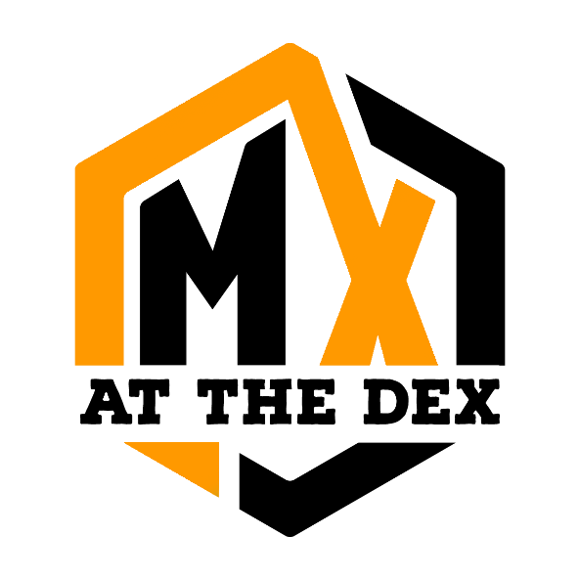
Marketing Report:

MX @ the DeX,

Huron, South Dakota

Executive Summary
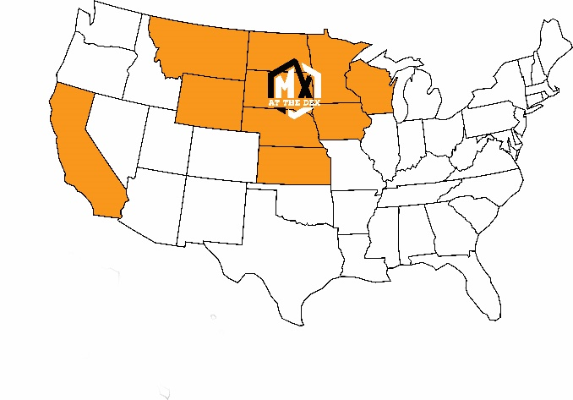
MX @ the DeX, an indoor motocross series hosted at the Dakota Events CompleX (DEX) in Huron, South Dakota, successfully launched its inaugural winter season in 2025. This report analyzes the event’s performance based on data from January, February, March and April 2025, as well as news media and social media engagement.
The series has attracted significant regional interest, drawing visitors and athletes from South Dakota, Iowa, Minnesota, North Dakota, Nebraska, California, Kansas, Missouri, Wisconsin, Wyoming and Montana. The strong community support and engagement has paid off with high visitor dwell times, consistent attendance, and incredible social media impact and positive review sentiment.
An estimated economic impact of the 4 races, 11 practices, 27 employees and 9,000+ visitors had a direct spending/economic impact on the Huron area that likely ranged from $255,000 to $630,000 for the 15 events. The indirect benefits of this event could potentially have impacted 2 times that amount for the region.

Event Overview
MX @ the DeX is a winter motocross series held at the DEX, a 150,000-square-foot facility at the South Dakota State Fairgrounds. The series, organized by 713 Racing Promotions, ran events on January 18, February 15, and March 15, 2025, with a final event on April 12. The events feature a professionally designed dirt track, laser lights show, a high-energy announcer, luxury suite accommodations, theme nights for the opening ceremonies, and a festival atmosphere with fan fests, merchandise booths, and concessions.

In Person Visitor Metrics

January – April Visits: 9.3K (PLACER AI reported phone carrying visitors)

Average Monthly Visitors: 2.5 K (higher than PLACER AI monthly total number to estimate non-phone carrying attendance)
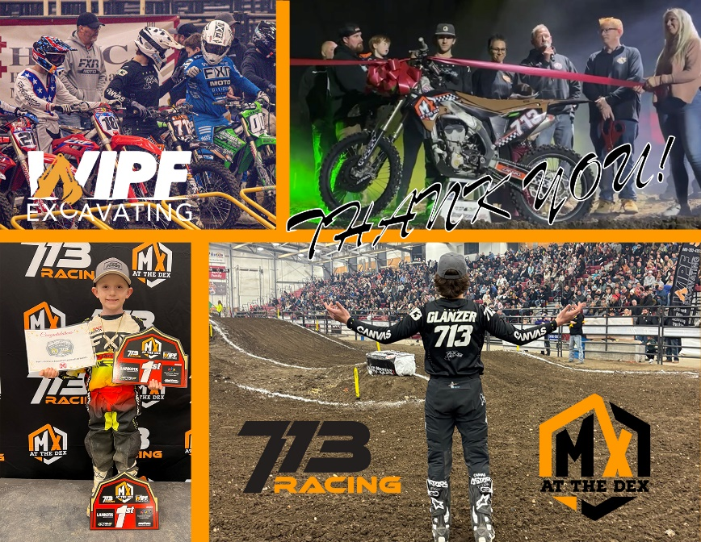
- Average Dwell Time: 5 hours and 4 minutes
- Top Visitor Origins:
  - Huron, SD (3,235 visits)
  - Volga, SD (633 visits)
  - Woonsocket, SD (548 visits)
  - Mitchell, SD (531 visits)
  - Brookings, SD (486 visits)
  - Sioux Falls, SD (474 visits)
- Visitors Also Used Nearby Locations:
  - McDonald’s (1,241 visitors)
  - Burger King (876 visitors)
  - Walmart (727 visitors)
  - Runnings (528 visitors)
  - Taco John’s (504 visitors)
  - Phillips 66 (428 visitors, 5.3%)

Social Media Engagement
The MX at the DeX Facebook page, YouTube Channel and Instagram Account provide insight into community engagement and event promotion. Facebook is used as a primary information outlet by the ownership group and post frequent updates.
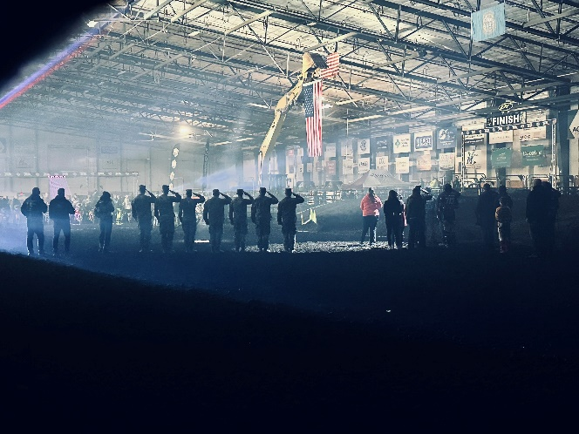
  - Page Stats:Facebook, the main source of social media posting for MX @ the DeX, boasts 3,500+ followers. The page was introduced on November 22, 2024 with no followers. In June, due to follower numbers and traffic, Facebook has monetized the account and the owner is receiving traffic payments from regional and national advertisers.

- December – April Engagement
  - Social media posts during this time received over 5.5 million impressions which is on pace with national brands like Crumbl Cookies, Hulu, the WNBA, Topps Sports Cards and exceeds national brands like Peacock TV and Smith and Wesson. During the month of January, MX @ the Dex’s Facebook page was among the top 60 of fastest growing pages in the USA based on views.

Marketing Successes
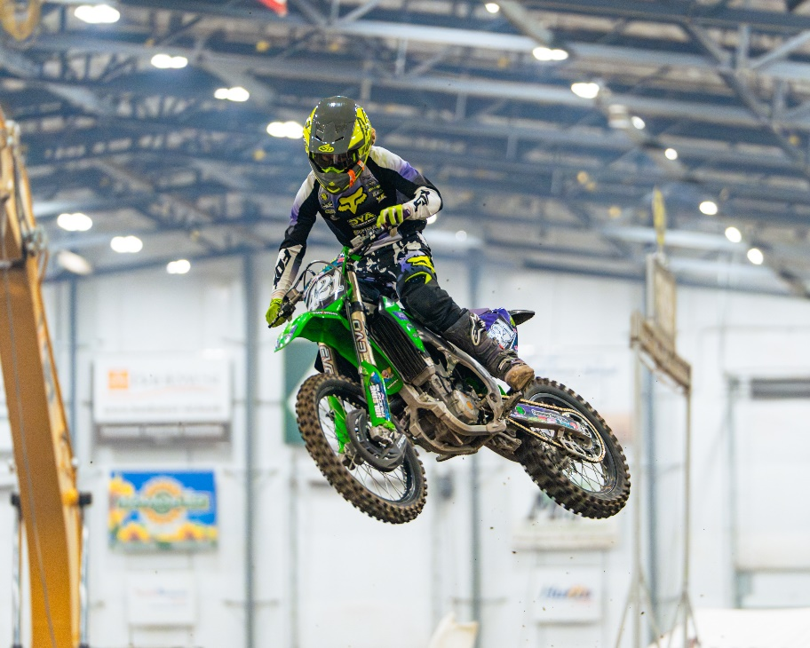
- Community Engagement: The event has fostered strong local support, with Huron described as a “race town” and partnerships with local and national businesses like Wipf Excavating, Flatland Concrete, Shawn Harvey’s Montgomery Real Estate, Huron Regional Medical Clinic, Iverson Auto and Iverson Motorsports, Carr Chiropractic, Butler Cat, Mike Cotton Trucking, The South Dakota State Fair, Castlerock Contractors, Touchstone Energy, Dakota Energy, Canvas MX, Rocky Mountain ATV/MC, Kawasaki National Accounts, RaceReady, Motosport.com, Rusty’s Fireworks, Runnings, Ellwein Distributing and LanKota.
713 Racing also extended free banner advertising space to all Huron area businesses located on Dakota Avenue due to a construction project on the town’s main street that made customer access difficult. 17 downtown merchants utilized this program.
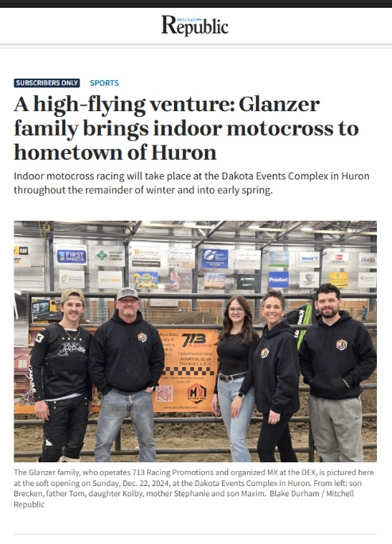
- Regional Appeal: The series has successfully attracted visitors from multiple states, fulfilling the goal of addressing a regional need for winter motocross, and entertainment options in the Huron area. The high dwell times, over 300 minutes, indicate an engaging experience that keeps attendees, athletes, and fans, in the town and on-site.
- Event Atmosphere: The combination of fan fests, merchandise booths, and high-energy production has created a unique, entertaining experience, as noted by owner Tom Glanzer’s “rock show where we also race dirt bikes” description to the local media.
- Media Coverage: Local and national media outlets like KELOland News, Dakota News Now, The Daily Plainsman, Mitchell Daily Republic, Yankton Press & Dakotan The Rapid City Journal, KWSN, WNAX, and KORN have covered the series, boosting visibility regionally and nationally. The analytics of each story ended with supportive statements, giving positive reviews. Coverage highlights the event’s professionalism, race-quality, and family-friendly nature as well as community impact. (These stories are worth an estimated $23,300 in earned media value for the local community.)
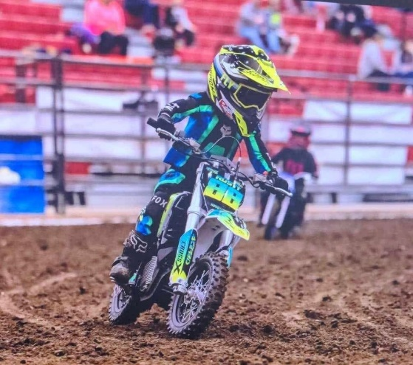
In year one, MX @ the DeX has established itself as a powerful addition to Huron’s event landscape, drawing significant crowds and fostering community pride. The Chamber of Commerce, City of Huron, Huron Bid Board, South Dakota State Fair, as well as, all advertisers can hold their head high that they were a major part of ensuring Wipf Excavating’s MX @ the DeX was a success in year one. The series’ following shows many visitors stay overnight and utilize local businesses high above event average. The regional appeal and positive social media engagement reflect a strong foundation and support from a wide range of communities. MX @ the DeX race and practice events brought thousands of visitors to Huron during the winter months when few events are happening.




